SB-CEU Program Participants:
If you will be using these SB-CEUs to renew your certificate/license in the Michigan Online Educator Certification System (MOECS), you will need to locate your Personal Identification Code (PIC) number and place it into your record on the Secure Central Registry (SCR) to have your SB-CEU credits appear in MOECS.
The following certificates/licenses are renewed in the MOECS:
Professional Teaching Certificate
Occupational (Vocational) Certificate
School Counselor License
School Psychologist Certificate
School Administrator Certificate

If you do not have one of the above listed certificates/licenses, you will not have a PIC number that needs to be put in the Secure Central Registry (SCR). You DO NOT need to go into MOECS or MEIS. Make sure the question on the first page you see in the SCR after you have logged in is answered NO.

Personal Information
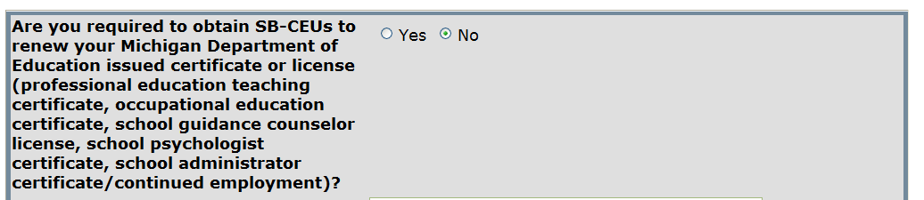

You can create, update, and access your evaluations on your SCR account
without a PIC. The PIC number is not mandatory.

LOCATING YOUR PIC NUMBER FOR MICHIGAN EDUCATORS
1.) For individual teachers, one way to obtain you PIC number is by contacting your Human Resources department in their district. The person in your Human Resources department would need to be the individual (s) who work with the Registry of Education Personnel (REP) report. If they do not have the PICs, they would know who the REP authorized user is for the district. The REP authorized user would be able to provide the PICs.
Preferred method to locate your PIC number:

OBTAINING YOUR PIC NUMBER FROM MOECS
- Go to the following web site: www.michigan.gov/moecs

http://www.michigan.gov/mde/0,1607,7-140-6530_5683_57223---,00.html
- Go to the MOECS login page by clicking on the logo at the top of the screen.
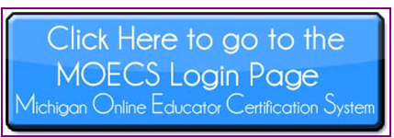
- If you are new to the MOECS system, click on the “Create MEIS Account” link. If you have already updated your MOECS account, skip to #10.*
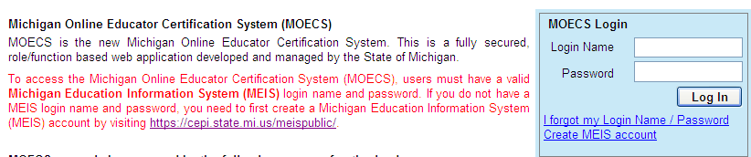

- Follow the instructions and provide the required information to create your login name and password.

- Print the confirmation page that contains your login name, password, and Michigan Education Information Systems (MEIS) account number.

- Click on the link to return to MOECS.

- Log into MOECS using the login name and password that you created.

- Once you have successfully self-registered in MOECS, you will be sent an e-mail that contains a link to activate your account.

- Click on that link and the MOECS login screen will appear.

- *Log into MOECS again, using the login name and password that you previously created.

- Update and save your demographic information.

- After you update and save your demographic information, the left navigation menus will appear on the screen.

- Select “Manage Demographics” from the left navigation menus.

- PIC numbers are listed above the “Education History” section.

*Applicants only need to create a login name and password and self-register in MOECS the first time they use the system. Once an applicant has created a password and login name and self-registered in MOECS, he/she can log into MOECS at any time to apply for a certificate, renewal, additional endorsement, or duplicate certificate, update demographic information, check the status of an application, etc.

